**Covid 19 testing data & positive cases Analysis – Indian states:**

Introduction & Description

Covid 19 is gripping the whole world and I was curious to know how my state is performing on Covid 19 situation in comparison with other states. Telangana is a state in India situated on the south-central stretch of the Indian peninsula on the high Deccan Plateau. It is the twelfth largest state and the twelfth-most populated state in India with a geographical area of 112,077 km2 (43,273 sq. mi) and 35,193,978 residents as per 2011 census (source: Wikipedia).

As of yesterday (16-Jun-20), Telangana has 5406 positive cases out of which 3027 are recovered and 191 deaths. Source: <https://covid19.telangana.gov.in/>

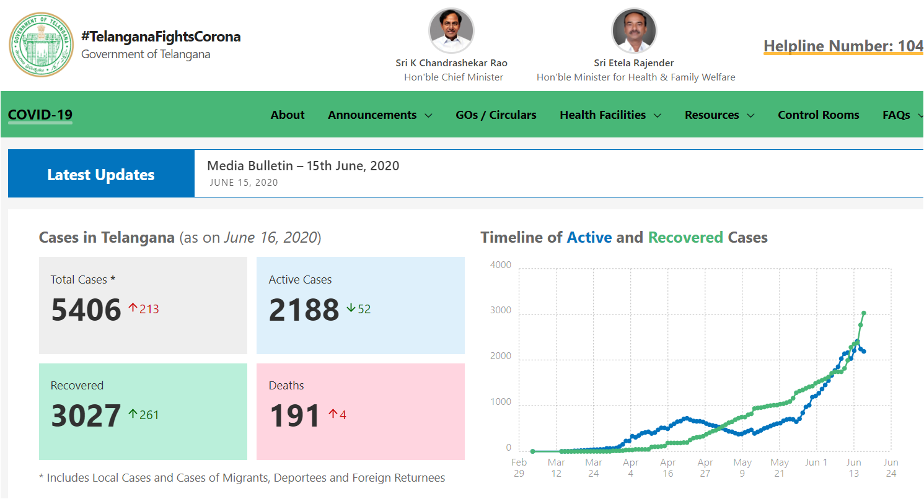

Data Considered:

1. For covid-19 data, I have used the kaggle dataset “COVID-19 in India”, which per collaborator is the latest available data. Source: <https://www.kaggle.com/sudalairajkumar/covid19-in-india/discussion/157935>
2. For state-wide population, I have used Wikipedia.

Source: <https://en.wikipedia.org/wiki/List_of_states_and_union_territories_of_India_by_population>

Methodology:

I have used python pandas, numpy to work with the datasets.

1. Covid 19 data from Kaggle

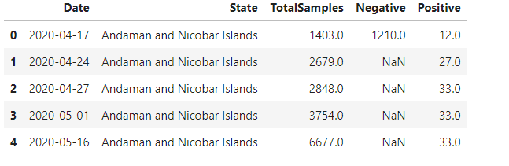

1. State wise population from wikipedia per 2011 consensus

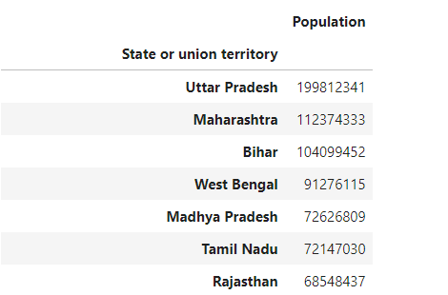

I have aggregated data according to the state.

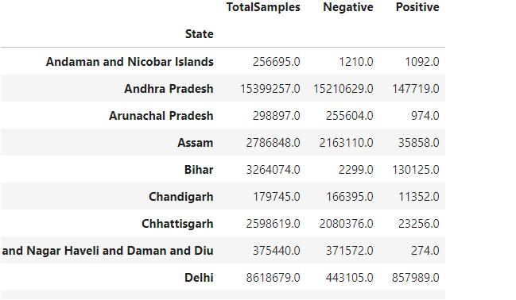

Merged the datasets and calculated percentage of testing (Ratio of Total samples to State population) & percentage of positive cases (Ration of positive cases to Total samples)

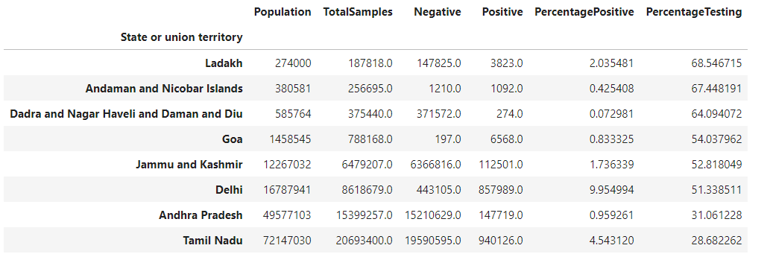

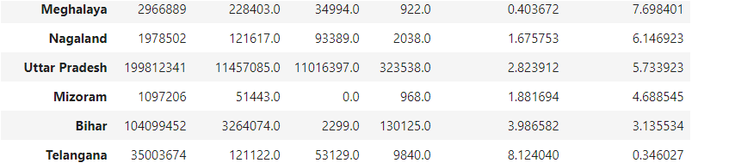

We can see some states have higher percentage of testing i.e. Ladakh, Andaman & Nicobar Islands….and some lower percentage of testing i.e. Telangana, Bihar, Mizoram.

We can see percentage of positive cases below:

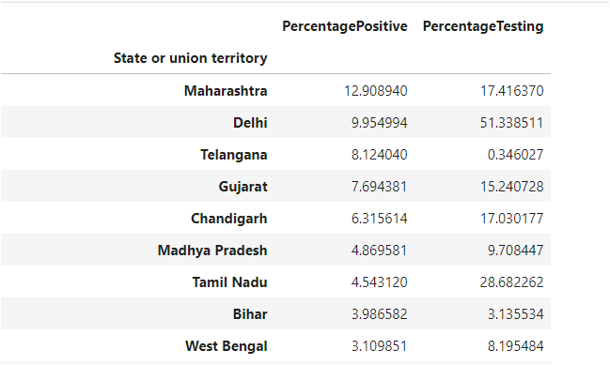

Telangana stands third in terms of percentage of positive cases.

I have done plotting for Percentage Testing and Percentage positive cases using bar graph.

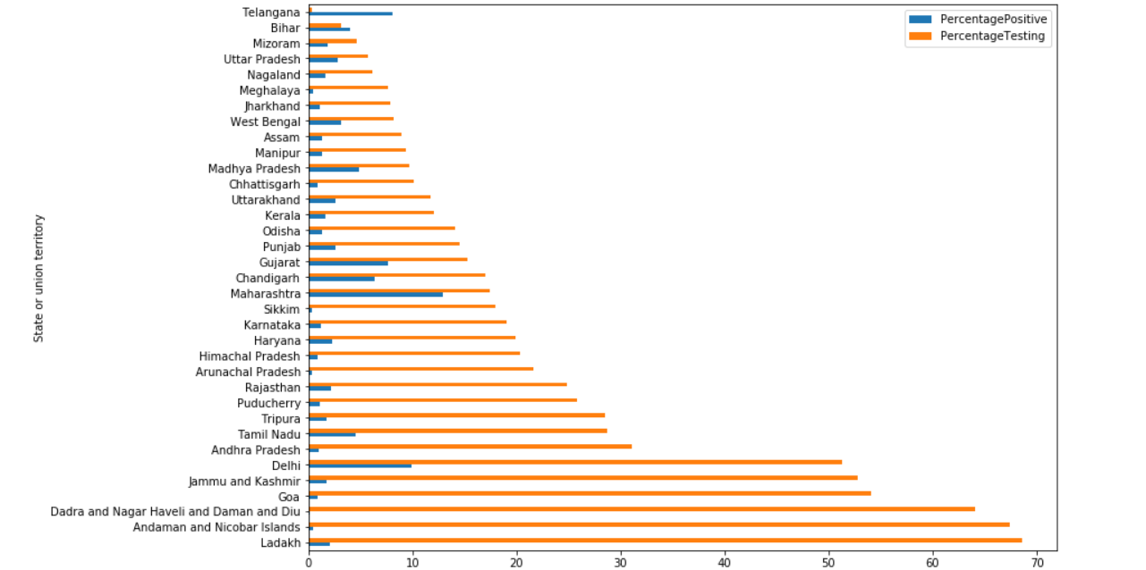

Some Statistics:

National Average:

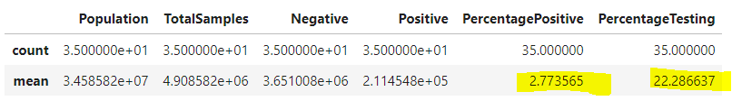

Telangana state percentage of testing stands at a mere 0.34% which is the lowest among all states. Its percentage of positive cases is 8.12%. It’s interesting to note Telangana state with the lowest testing percentage is among the states with high percentage of positive cases i.e. 8.12% which is way ahead of the national average (2.77%).

Conclusion:

I am not an expert on pandemic control models but being a guy who works around data, the insights drawn above conclude Telangana state adopted model of need-based testing has not yielded anticipated results and the state has to consider increasing testing samples. With an increase in testing, there could be a significant rise in the number of Covid 19 cases. These cases which are presently not accounted could pose a significant risk to the community as they are undetected and could cause an underlying widespread.

For a better future,

Kanthi Lakkakula

References:

1. Kaggle Covid-19 Dataset: <https://www.kaggle.com/sudalairajkumar/covid19-in-india?select=StatewiseTestingDetails.csv>
2. Wikipedia: <https://en.wikipedia.org/wiki/List_of_states_and_union_territories_of_India_by_population>